VICE PRESIDENT REPORT EUROPE

Europe, like other continents, is waking up painfully from the pandemic that has rocked it for 2 years. Today, the dairy economy is stable with milk production increasing very slightly. The result is a very moderate increase of the milk price. However, many farms are at risk with the current extreme rise of production costs.
Despite everything, Jersey continues to develop across Europe. Exports of heifers to eastern countries and to the Mediterranean are still strong.
We continue to exchange regularly on different topics and issues.
Several countries are conducting research and developing projects around the male line, whether in pure breed or crossbred with beef breeds. Aware that the female line around the use of sexed semen should be used with moderation to fit into the heifer market. The male path is today identified as a brake on the breed development.
Significant work is being done on feed efficiency. This is an essential step for the future when we talk about the carbon impact of livestock farming, methane reduction, etc.
Not to mention animal welfare, or even the Charter of Organic Agriculture, which requires breeding schemes to speed up work around the “hornless” gene.

If life is slowly picking up, competitions are also starting up again. Despite this, the movement of people between countries remains complicated. We were forced to cancel our 2021 annual European Jersey Forum meeting.
However, it was decided to innovate and organize the first European Jersey Online Show early July:
10 countries joined the show: Cyprus, Czech Republic, Denmark, France, Germany, Italy, Nederland, Luxembourg, Switzerland and the United Kingdom. In total 66 jersey including 17heifers and 49 cows took part.
3 judges shared the classes and judged all together the championships. Among them:
DIEGO SIERRA CALDERON from COLOMBIA judged the heifers’ classes.
HERBY D. LUTZ from USA judged young cow’s classes.
POENA VAN NIEKERK from SOUTH AFRICA judged the senior classes.
This online show was a good opportunity to bring together cows from different countries and see amazing cows. The audience was there with an average of 160 likes per post and 5300 people touched each time. Videos have been seen 27 000 times in total!
The senior championship gets the most attention with 380 likes, 2600 views and almost 9000 people touched! Visitors flocked from all over Europe and even beyond. France has the highest rate of visitors with 19% followed by Denmark 13% and Italy 9%. Outside of Europe, 3.5% of the visitors were from Canada. A great success, while perhaps waiting to be able to hold a “real” European show one day!
Before that, we had to discuss our competition rules together (cows registered in herdbook, no JX, AI issues, clipping, etc.). This event also allowed us to meet breeders from several countries that do not have a national association.

We now hope to be able to meet you next year in France around a varied program consisting of tourism visits (St Malo, Landing beaches, etc.), farm visits, technical meetings, and the National Jersey show during SPACE 2022, one of the biggest French agricultural exhibitions in Rennes.

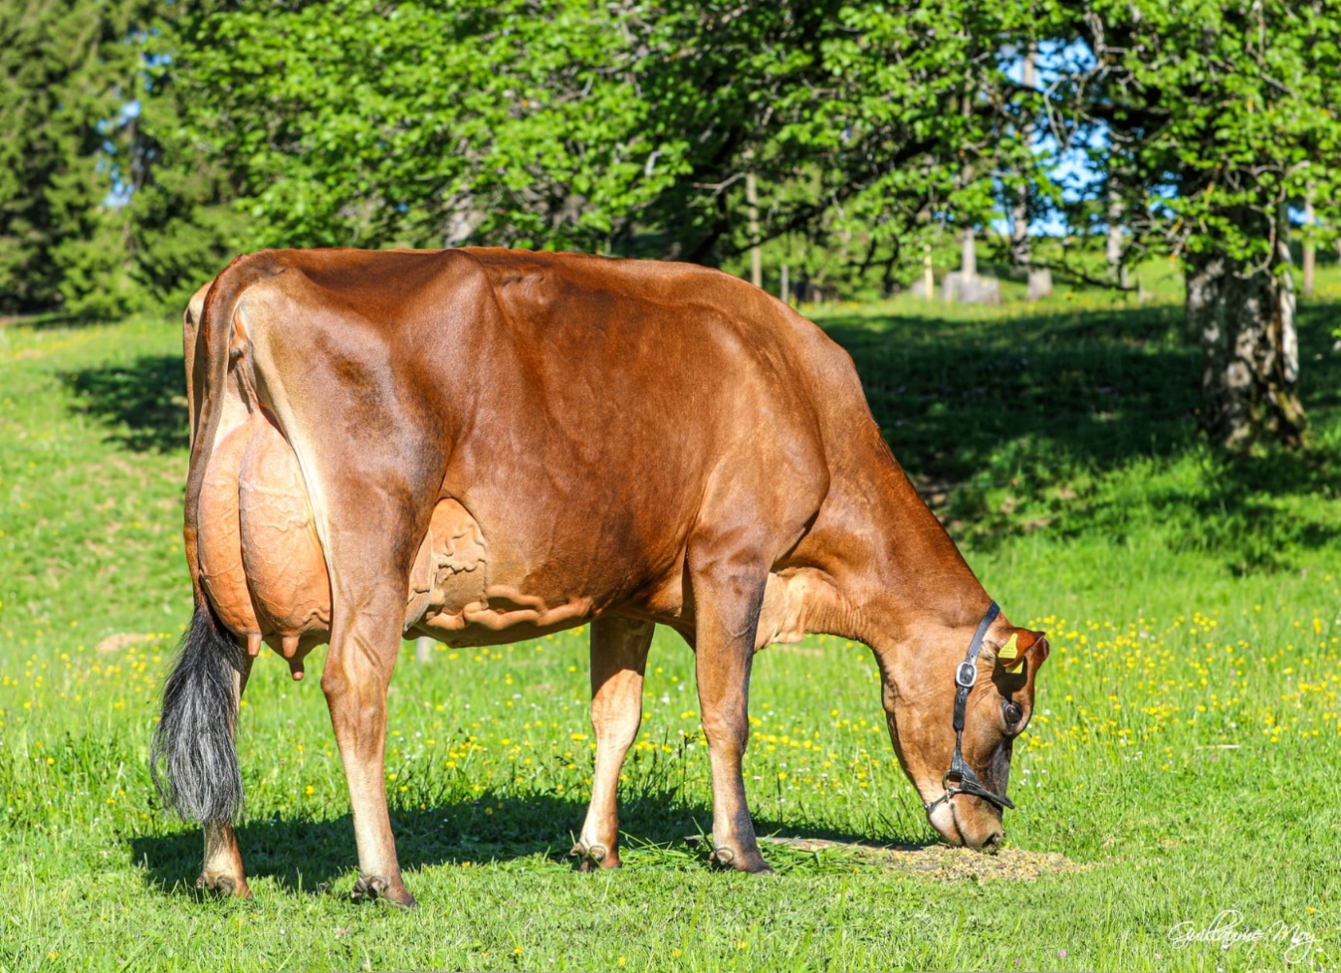
Rocmountain Barnabas RACHELLE from Mr Christophe ROHRBACH (Switzerland) _ Grand Champion of the first online European show. Photo credit: Guillaume MOY photographies

Les Pézerils, Izé (France), the 03/11/2021
The Vice President of WJCB for Europe

Benoit GUIOULLIER

