Vice President’s Report – Oceania September 2022
New Zealand
Strategic Plan 2022/23
CORE PURPOSE: Supporting our membership and the wider Jersey community by promoting the Jersey breed and Jersey products
BHAG: Jersey #1 Breed – Adding integrity and value to your farming business
VISION: Recognised for leading in
- Profitability and efficiency
- Genetic Gain
- Consumer Preference
- Membership and Engagement
- Reduced Environmental Footprint
- Animal Welfare

CORE VALUES: Integrity Sustainability Quality Collaboration

Member Services

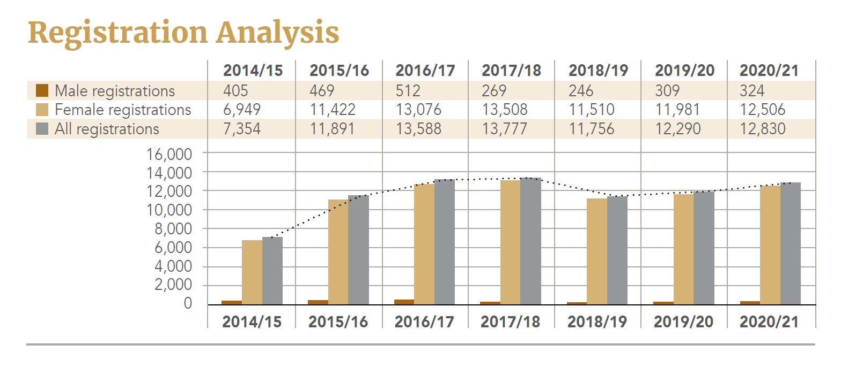

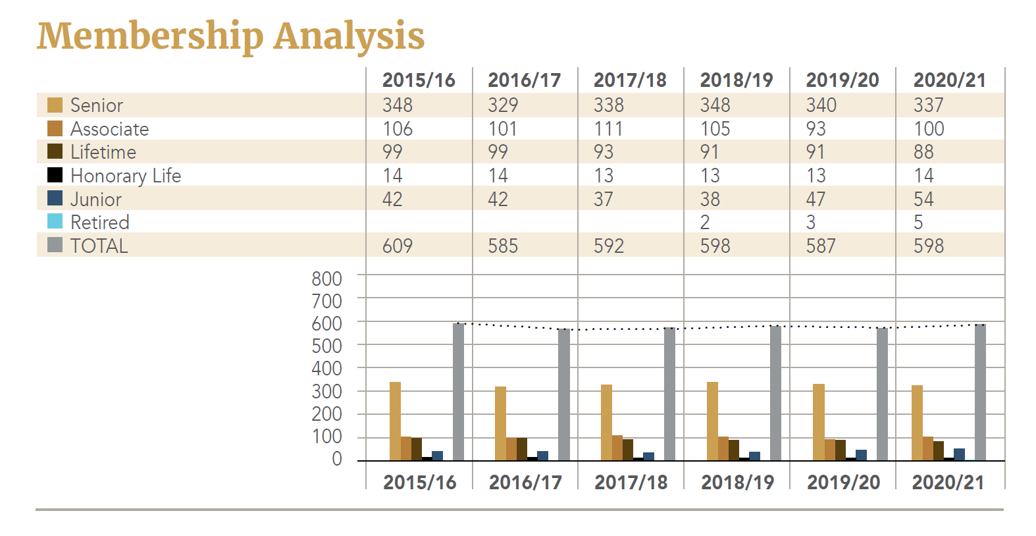

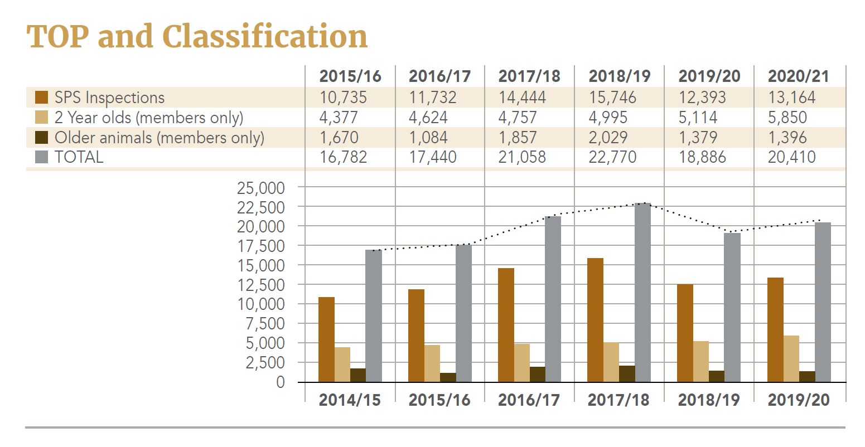

Major Activities
In 2010, Dairy NZ reviewed the National Animal Database which included who would have direct access and how who would manage this “new” database. In the days of the unregulated Dairy Industry the Dairy Board and Livestock Improvement were recognised as the Industry Good providers. Once Livestock Improvement became a corporate with farm owner shareholders, the situation changed. It became necessary to distinguish between what is Industry Good related work and what are products and services enabling a corporate to make a profit. Thus began the DIGAD (Dairy Industry Good Animal Database) discussion.
Twelve years on and during that time the Breed Societies of New Zealand have collaborated and developed an IT programme and in June 2021 the BreedIT platform became operational. This programme deals with all the registration, TOP and classification data and is an independent interface between LIC, CRV Ambreed and NZAEL. At the initial stages there were naturally the teething problems but we are now at the final milestone of reporting. This should be complete by November of this year. With BreedIT came the opportunity to review our classification awards and we are now much more aligned internationally and generally our members are embracing the changes.
In May 2021, JerseyNZ and Jersey Advantage, purchased a 215ha farm in Southland. A separate board was set up to provide the governance of this initiative and operate under the name of Jerseyland Farms. A year on and we are very pleased with how the farm is progressing with a projection of an increase of 10-20% production (250,000 KgMS). The excellent payout has also enabled the board to concentrate heavily on the reduction in debt and most importantly JerseyNZ and Jersey Advantage have received dividends.
Our relationship with Massey University enables us to be involved with up-to-date information on their “Once-a-day” research. Massey No 1 Dairy Farm is located between the Massey University campus and the Manawatu River, encompassing 142.7 hectares (119.7ha effective) of free-draining recent alluvial soils.
This farm produces milk with a spring calving herd comprising 75 Friesian, 56 Jersey and 119 Friesian x Jersey crossbred cows under once-a-day milking during the entire season, all selected using a once-a-day selection index. The cows are milked through a 24 a-side herringbone shed equipped with the Westfalia Metatron® system. A concrete feed-pad with 300 cow capacity is located close to the shed to increase supplement utilisation. The herd changed from twice a day to once a day milking in the season 2013.

Achievements
- A successful pivot to the way that we interact with members during Covid, including our team working from home for long periods
- Continued financial success throughout two years of Covid lockdowns without having to access government assistance
- The sale of the Deed of License to the wing at LIC and the move for the office into the CBD fringe
- The continued success of the Jersey Future programme with sales increasing year on year
- The significant investment in Jerseyland Farms Ltd, ensuring the financial sustainability of our organisation
- The adaptation of our team to absorb all administrative functions for Jerseyland Farms
- Our successful and continuing collaboration with Jersey Advantage
- The important industry work undertaken by the Industry Affairs and Genetics Committees, ensuring that the Jersey NZ voice continues to be heard
- Good staff retention with only one permanent change in over three years
- Our fully owned subsidiary Link Livestock going from strength the strength, increasing their sales force and returning a dividend to Jersey NZ
- The successful retention of the contract to undertake all administration for Ayrshire New Zealand
- The continued success of the JerseyGenome joint venture with young bulls selected for progeny testing
- Successful debt reduction following the Jerseyland Farms investment
- Increased TOP member inspections following the changes to the award system
- The implementation of BreedIT which, once complete, will allow further bespoke programme and core service efficiencies
- Excellent sale prices for Jersey animals including some new breed records
- Jersey bulls continue to dominate the RAS list
- Increased Jersey Focus advertising following the change in publication timing

Industry Initiatives
Polled Jerseys: Consumer demand has put a great deal of pressure on the way we farm and from an animal welfare perspective the “dehorning” practice has come under a great deal of scrutiny. Historically the polled genetic base has been very small in New Zealand but we are now starting to see an increase in the availability of these genetics. One of our members, Bruce Cameron (Ardachie Jerseys), has been breeding polled jerseys for years, a continuation of his father’s work, and has been very influential both here and overseas. Ardachie Overlord PP has many daughters in the EU. JerseyNZ was delighted to honour Bruce at our recent conference with the Distinguished Members award and the George Henry Dawick Memorial Cup in recognition of this fantastic work.
Bobby Calves: A worldwide issue that won’t be going away anytime soon. Our Industry Affairs Committee under the leadership of Roger Ellison has undergone considerable work in getting a seat at industry tables to ensure our voice is heard and that we have valuable input into the decision-making process. In particular Dr Ina Pinxterhuis of DairyNZ has spoken with our committee in order to gain valuable farmer insights around this issue.
Environmental Issues: Again, a worldwide issue. In New Zealand, He Waka Eke Noa is the name of a group of stakeholders who have been tasked with developing a farm specific method to estimate and price the methane and nitrous oxide emissions derived from animals. It is a joint government, primary industry initiative that, if deadlines are met, means that we dairy farmers will not become part of the emissions trading scheme (ETS). The ETS is a blunt tool, mostly operating at industry level that would mean individual farmers would lose control of how they manage their emissions. Roger Ellison and Trish Rankin, members from JerseyNZ, along with members from Jersey Advantage have been advocating on behalf of Jersey farmers and has been in discussions with senior representatives from Fonterra, DairyNZ and He Waka Eke Noa.

Australia
Strategic Objectives
- Maintain and grow the Association relevance
- Provide strong governance and leadership
- Financial stability
- Maintain and grow the Jersey breed
Member Services
Herds Registering
 | 2015/16 | 2016/17 | 2017/18 | 2018/19 | 2019/20 | 2020/21 | 2021/22
NSW | 71 | 60 | 72 | 65 | 62 | 60 | 57
QLD | 33 | 23 | 27 | 25 | 24 | 18 | 29
SA | 14 | 8 | 15 | 17 | 15 | 12 | 13
TAS | 12 | 3 | 10 | 16 | 10 | 5 | 7
VIC | 159 | 124 | 151 | 171 | 135 | 127 | 133
WA | 5 | 3 | 3 | 3 | 2 | 3 | 4
Total | 294 | 221 | 278 | 297 | 248 | 225 | 243

Animals Registered
 | 2015/16 | 2016/17 | 2017/18 | 2018/19 | 2019/20 | 2020/21 | 2021/22
NSW | 2402 | 3155 | 2202 | 2348 | 1355 | 1532 | 952
QLD | 360 | 729 | 408 | 532 | 232 | 287 | 734
SA | 357 | 365 | 321 | 364 | 341 | 182 | 175
TAS | 353 | 330 | 507 | 343 | 224 | 449 | 140
VIC | 6141 | 7592 | 5429 | 5655 | 5330 | 5928 | 5632
WA | 15 | 40 | 37 | 18 | 18 | 6 | 31
EXPORT | 1779 | 8211 | 9368 | 7029 | 4511 | 0 | 0
Total | 11407 | 20422 | 18272 | 16289 | 11999 | 8409 | 7687

New Members
2015/16 | 2016/17 | 2017/18 | 2018/19 | 2019/20
34 | 19 | 18 | 20 | 37
Current Membership = 486

Herds Classified
 | 2015/16 | 2016/17 | 2017/18 | 2018/19 | 2019/20 | 2020/21 | 2021/22
NSW | 50 | 49 | 47 | 52 | 40 | 42 | 24
QLD | 20 | 23 | 20 | 19 | 8 | 0 | 16
SA | 11 | 11 | 89 | 12 | 10 | 4 | 10
TAS | 9 | 7 | 120 | 8 | 10 | 7 | 4
VIC | 108 | 115 | 2 | 116 | 110 | 97 | 97
WA | 1 | 2 |  | 1 | 0 | 0 | 3
GINFO |  |  |  | 8 | 31 | 69 | 60
LTE |  |  |  | 17 | 5 | 10 | 10
Total | 199 | 207 | 206 | 233 | 214 | 229 | 224

Cows / Heifers Classified
 | 2015/16 | 2016/17 | 2017/18 | 2018/19 | 2019/20 | 2020/21 | 2021/22
NSW | 795 | 932 | 962 | 954 | 503 | 700 | 580
QLD | 201 | 268 | 255 | 245 | 162 | 1 | 331
SA | 190 | 120 | 109 | 186 | 89 | 56 | 126
TAS | 185 | 106 | 172 | 116 | 162 | 169 | 140
VIC | 2514 | 2857 | 289- | 3139 | 2810 | 2829 | 3275
WA | 3 | 15 | 24 | 19 | 0 | 0 | 35
GINFO |  |  |  | 441 | 1409 | 2253 | 2348
LTE |  |  |  | 231 | 46 | 92 | 205
Total | 3888 | 4298 | 4412 | 5331 | 5181 | 6100 | 7040

Major Activities / Achievements
- Restructured the Board and Management structure to ensure the Board’s key focus is on strategy, governance and policy.
- Implemented key sub-committees to provide detailed review and recommendations to the Board in Genetics and Promotions
- Completed the successful “Jersey’s Most Profitable and Sustainable Cow” Project detailing the key benefits of the Australian Jersey cow. This was a cornerstone project for the Association and the findings were presented by Dr Steve Little at the WJCB Online Conference in April 2022. A download of the project findings can be found on the Jersey Australia website at: https://jersey.com.au/jersey-most-profitable-cow-project/
- Developed and implemented new marketing strategies and branding providing fresh logos, Dairy’s Finest Brand development, 5-Star Jersey cow initiative and a Jersey milk promotion.
- Re-established our industry relevance through supportive engagement and participation in key priority areas and stakeholder groups.
- Implemented a new breed registry an increase and improved service delivery to members and stakeholders.
This work has been led through the recognition of a need to change, adapt and grow the Association. We have achieved the re-laying of the foundations; now is the time to set the pathway forward. The Board has, or is in the process of, setting several key objectives and activities. This takes investment, both financially and resources, and will take the commitment of, not many but all, to reach our goals.
- International Dairy Week is back and this year a great display of Jerseys was presented for judge Mr Brian Wilson.
- A newly appointed Field Service Officer to grow the association through an increase in membership and services.
- International growth opportunities with strong semen sales into Africa and marketing opportunities developing strongly into North America and Europe, with strong interest in Pakistan and India.

Industry Initiatives
- The Association has had key participation in the DataGene Genetics Standing Committee, Dairy Australia South Coast Surplus Calves Pathway Project and the Ginfo Project.
- Worked with other Breed Associations and Stakeholders in exploring opportunities to enhance Australia’s genetics export opportunities where we see enhanced value in a team approach to support a strong Australian genetics market.

As I compile this report on behalf of Oceania, both New Zealand and Australia are sitting on high alert with the news of the outbreak of Foot and Mouth in Indonesia. Neither country can afford for this to escalate and infiltrate our borders. While our governments do their best, one is left wondering – will it be enough!

Alison Gibb
Oceania Vice President
World Jersey Cattle Bureau

