latin america report wjcb

december 2021

Jacobo L Cabassa

president Latin American Forum

Vice -president wjcb

wa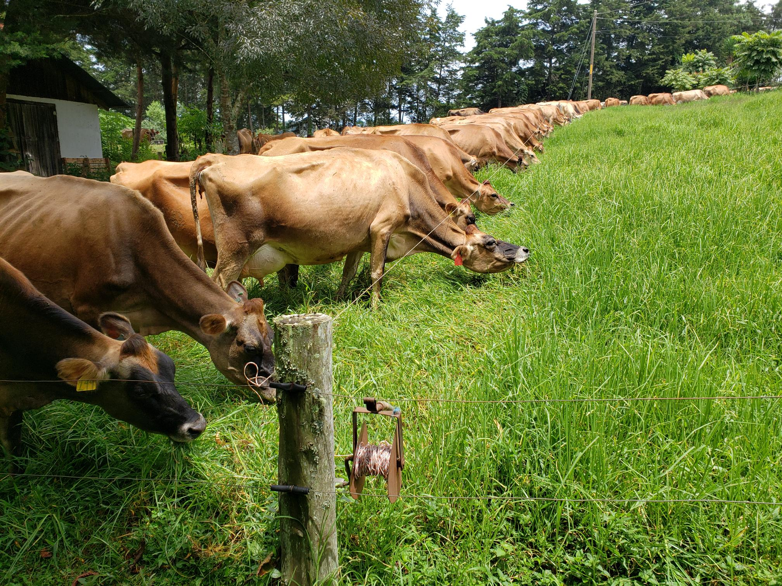
I am deeply grateful to the Bureau and the many Jersey friends that have made these two years such a pleasant and fulfilling journey. The Jersey breed in Latin America is growing in numbers and value producing efficiently the highest quality and tastiest milk in the market. In the same way the breeders have been extremely active holding the expositions, virtual reunions and breed promotion activities to make Jersey the most popular milk cow in Latin America.

Country Reports:
- Argentina-Dificult year due to Covid restrictions, no expositions held, visits to farms suspended, Jersey milk 20% higher price, imported semen grows every year, Holstein breeders cross breeding with Jersey, JX semen popular 50% of Jersey semen imported, large demand for Jersey heifers short supply of females, the association gives strong support in marketing and veterinarian services to members and potential new breeders
- Colombia- some limitations in farm visits but renewed expositions 2021, excellent results and numerous activities, we had first Latin American Forum in July 2019 with large participation of members of the majority of the country associations , in September 2021 a virtual conference Jersey de Norte a Sur- In Spanish with a virtual message and visit of President Steve Le Feuvre and Secretary Roger Trewella, Outstanding breeders with excellent results and stiff competition in all the expositions, next year celebrating 40 years since the association was established, offered to host 2022 Forum but the members selected Ecuador.
- Costa Rica-probably one of the best organized Dairy producers in Latinamerica, Dos Pinos largest Coop in Central America this year started a plant in Guatemala, the association after the Forum in Colombia inaugurated the monthly Academia de Criadores Jersey which has been held on the last Wednesday of every month with excellent speakers from all Spanish speaking countries all the meetings are available in You Tube. Eduardo Robert the current president of the association and leader of the Academia is being proposed to continue his work as VP for Latin America.
- Ecuador- will host 2022 Forum in July in Quito when they will celebrate 60 years of the association initiation during the country biggest exposition. Breed in full growth and popularity
- Guatemala- Jersey is by far the most important milk breed, solid membership over 100 members and over 4,600 registered Jersey, solid financial position only breed that manages its expositions, has a quarterly magazine and multiple breed promotional activities, Jersey started with imports in late 1890s. Guatemala issued invitation to Bureau to manage 2023 World Conference with post conference tour connection to Mexico Queretaro and San Miguel Allende.
- Mexico has been hit hard with the Pandemia but membership is re grouping and gaining strength they have a strong participation in the annual exposition held late November in Quertaro, beautifull city and good wine country, working in studying Jersey crosses for hot climates.
- Uruguay had a strong participation in the Colombia Forum but was not able to send a country report as well as Chile, Peru, Venezuela.

Awards, special recognitions, recommendations for future actions and activities.
- One of our proposals was the preparation of a country information report to permit the Bureau to produce a World Breed activity and compilation report so we would have a measure of new developments in registrations and breeders reports. Thank you Melina Abarca and our Secretary Roger Trewhella for a great set up. Although we could not group the European groups we advanced a lot in the Latin American countries and will continue the work we feel it is of great importance to continue this work.
- I also have a personal proposal to present to the Bureau for evaluation, Jersey breeders are special persons extremely active, enthusiastic and hard workers they love their cows and are enthusiastic show participants but I notice we do not produce much information on the benefits of Jerseys as producers of quality milk economically and very little attention or promotion appears to be developed in this area and to me it is the first reason to have Jersey cows is to produce and sell milk at the best price. Lest promote some more enthusiast to study this area. The last area is that JX bulls may not be such a negative factor if milk producers keep looking to build the most competitive milk producing machine it has to be Jersey foundation.
- I want to express my gratitude to so many enthusiastic breeders and workers I received excellent support and assistance from every person I asked for help not one NO! ever!
- I will show some names but beware at my age remembering is a lot of names is a tremendous challenge but I will try a short list: Eduardo Robert, Liliana Quevedo, Melina Abarca, my buddy Agustin Robredo, Byron Solis, Roberto Paez , Jose Roberto Jarquin, Rene Montenegro, Alejandro Flores, Jose Billeb, Roger Trewhella, John y Thelma Bailey, Manuel Zorrilla, Luis Joaquin Gomez Meza, Paolo Borello, Steve Le Feuvre, Derrick Frigot, Allison Gibb, Gonzalo Maldonado, Bruno Schuller, etc etc etc Thank you for all the good moments we shared, I hope we can keep meeting many more years.
- THANK YOU MY FELLOW BREEDERS ANA LUISA AND I WILL CONTINUE TO JOIN YOU IN ALL THE FUTURE CONFERENCES AND ACTIVITIES WE HAVE ENJOYED EVERY REUNION!

Utilice los estilos para dar formato fácilmente a los documentos de Word en un momento:
- Por ejemplo, este texto usa el estilo Lista con viñetas.
- Vaya al grupo Estilos, que encontrará en la pestaña Inicio de la cinta de opciones, para aplicar el formato que desee con un solo clic.

