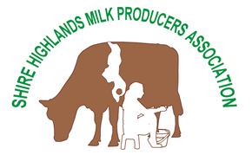
SHMPA
Box 30603
Blantyre 3
Tel: 01 875 257 / 0888 838 109
Request for Affiliate Membership for of WJCB by
Shire Highlands Milk Producers Association (SHMPA)
1st December 2021
To the Bureau Secretary
WJCB
SHMPA is an association of 12,000 smallholder dairy farmers in the south of Malawi. Between us we produce 95% of the milk that is marketed in this country.

The association provides AI services to its members and since 2017 our main source of semen has been RJAHS. We had been using Jersey semen over the previous 2 decades (from NZ, USA and RSA), but are particularly attracted to the smaller cattle originating from Jersey island which should cope better with the feeding constraints common to smallholders.

We also maintain a herd recording scheme which provides basic data on growth rates, death rates and calving rates. This should enable us to make comparisons between the different strains of Jerseys and other breed combinations.

Other work we are doing on breed improvement involves linking genetic type to performance (through hair sampling), which hopefully will add to the picture and help with the selection of breeding bulls for natural service.

The activities above ensure that SHMPA in Malawi will be able to contribute to and benefit from Herdbook consolidation of animal data in association with other African Jersey Forum members.

I hope SHMPAs membership will help draw attention to the importance of the Jersey breed to smallholder farmers with limited resources in many parts of the world. You have a fantastic resource in cows which are easier to feed but it needs to be understood and preserved before it is lost in rush for bigger and hungrier animals.

Yours faithfully,

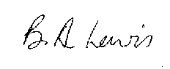

Brian A Lewis
Advisor, SHMPA

